**Drivers and Determinants of Variation in Albendazole Pharmacokinetics: Insights from a Systematic Review and Meta-Analysis**

Charles Whittaker1**,** Annette C. Kuesel2, Cédric B. Chesnais3, Sébastien D.S. Pion3, Joseph Kamgno4, Martin Walker5, Maria-Gloria Basáñez1* & Michel Boussinesq3*

1Department of Infectious Disease Epidemiology, Imperial College London, London, UK

2UNICEF/UNDP/World Bank/World Health Organization Special Programme on Research and Training in Tropical Diseases (TDR), Geneva, Switzerland

3Institut de Recherche pour le Développement (IRD), Montpellier, France

4Centre for Research on Filariasis & other Tropical Diseases, and Faculty of Médicine and Biomedical Sciences, University of Yaoundé I., Yaoundé, Cameroon

5Department of Pathobiology and Population Sciences, Royal Veterinary College, Hatfield, UK

* Indicates joint co-authorship

**Keywords:** Albendazole, pharmacokinetics, treatment, parasitic infections, helminthiases

**Key Points:** A systematic review and population pharmacokinetic modelling approach was undertaken to explore the drivers of the variation in Albedazole’s pharmacokinetics. This work revealed the role of gastric factors, age, sex and co-administration of different drugs as significant determinants of Albendazole’s pharmacokinetic profile.

**Abstract:**

**Background:** Albendazole is an anti-parasitic medication used in a wide array of both clinical and programmatic contexts. Significant inter- and intra-individual variation in the pharmacokinetic profile of Albendazole and its pharmacologically active metabolite, Albendazole Sulfoxide, has been observed. This variation is thought to have important consequences for treatment success, but our understanding of the factors driving this variation remains far from complete.

**Methods:** A systematic review was carried out to identify references containing temporally disaggregated data on the blood concentration of Albendazole and/or Albendazole Sulfoxide following a single oral dose. These results were integrated into a modelling framework in order to infer key pharmacokinetic parameters and relate them to characteristics of the populations being treated: age, weight, sex, dosage, infection status, and whether patients had received a fatty meal prior to treatment or other drugs alongside Albendazole.

**Results:** We identify a number of factors systematically associated with Albendazole pharmacokinetic variation. These factors impact different aspects of the pharmacokinetic profile: whilst Age is a significant determinant of Albendazole Sulfoxide half-life, a fatty meal prior to treatment was associated with increased Albendazole Bioavailability (and by extension, CMax­­ and AUC). Parasitic infection was also a significant determinant, with infected populations displaying distinct characteristics to healthy ones. Overall, these factors explain between 38% and 70% of the observed variation in the collated pharmacokinetic profiles, depending on the parameter. We also identified a number of interactions between Albendazole and other typically co-administered drugs.

**Conclusion:** These results provide insight into the mechanisms underlying the variation in Albendazole’s pharmacokinetics, highlight key biases in which populations have previously been studied during research into Albendazole, and suggest potential avenues for programmatic optimisation of the drug’s delivery.

**Introduction**

Albendazole is a broad-spectrum medication used widely in the treatment of a variety of parasitic worm infections. Historically, usage has primarily been in a clinical context where multiple-dose regimen are used to treat (neuro-)cysticercosis1 (caused by infection with *Taenia solium*) and echinococcosis2 (caused by various members of the *Echinococcus* genus) More recently however, it has also found extensive use in programmatic contexts, where a single dose has been delivered to communities as part of treatment for infections including those with soil-transmitted helminths3 (*Ascaris lumbricoides*, *Trichuris* *trichuria*, *Necator americanus* and *Ancylostoma duodenale*), lymphatic filariasis4 (delivered alongside ivermectin or diethylcarbamazine, although see recent work calling its relevance in these formulations into question5) and in individuals whose loiasis burdens are high enough to preclude safe treatment with other anti-helmintics such as ivermectin6, amongst others.

Despite this widespread usage, significant uncertainty still remains surrounding the usage of Albendazole. In particular, whilst therapeutic efficacy has been established for a wide array of helmintic parasites, Albendazole’s pharmacokinetics (and those of its pharmacologically active metabolite, Albendazole Sulfoxide) are characterised by extensive inter and intra-individual variation. This variation has been consistently observed across a wide range of studies (see Jung Cook, 20127 for a review and its implications for treatment), with the phenomenon typically attributed to a combination of the drug’s limited solubility in the gastrointestinal tract and extensive first-pass metabolism by the liver (responsible for converting Albendazole to Albendazole Sulfoxide) – in turn, this variation is thought to contribute to the failure of cure in some patients treated for diseases such as neurocysticercosis7. For example, whilst some patients typically require only one course of treatment, others require multiple treatment regimen, and in a limited number of instances, failure of treatment has also been observed8,9. This variation in outcomes observed in clinical settings has also been seen in field studies10, where for example, cure rates for infection with hookworm treated using the drug have been observed to vary from 53% to 95% across different communities in Ghana. Similar variability in Albendazole’s efficacy has also been observed for programmes treating lymphatic filariasis in the Democratic Republic of Congo11.

Whilst numerous factors associated with this variation have been explored in the literature, our understanding remains, for the most part, incomplete. A number of studies have examined the influence of different drivers, including sex12, co-administered drugs13,14, delivery of the dose alongside a fatty meal15,16 and infection status17 on the pharmacokinetic profile of Albendazole and/or Albendazole Sulfoxide. Frequently however, these studies have focussed on only a single factor, and so a systematic understanding of the exact determinants and drivers of this variation, their comparative impact, and whether they interact with one-another, remains outstanding. A better understanding of these factors is important given Albendazole’s usage around the world in programmatic contexts characterised by infrequent delivery (typically annually or biannually) of only a single dose. Insight into mechanisms by which to optimise the pharmacokinetic profile of Albendazole delivered in this context could therefore have significant public health relevance.

Motivated by these outstanding questions, we conducted a systematic review of the literature in order to identify references containing temporally disaggregated information on Albendazole and/or Albendazole Sulfoxide concentrations in the blood following treatment with a single oral dose. To this data, we fit a pharmacokinetic model of Albendazole and Albendazole Sulfoxide’s dynamics that captures key phenomena associated with the drug’s metabolism, including extensive first-pass metabolism18 and its established low bioavailability19. We fit this model to data collated as part of the systematic review in order to infer key pharmacokinetic parameters, including Albendazole bioavailability, Albendazole Sulfoxide half-life, AUC and CMax. We then relate these parameter estimates to characteristics of the patient populations being treated and the treatment regimen they received. In doing so, we provide new insight into the drivers of the extensive variation observed across Albendazole pharmacokinetic studies and provide programmatically relevant recommendations for use of the drug.

**Methods**

**Systematic Review of Albendazole Pharmacokinetic Literature**

Web of Science and PubMed databases were searched on 4th July 2019 using the keywords “Albendazole” AND (treatment* OR dose* OR pharma* OR “half-life” OR “half life”) in order to identify references containing temporally disaggregated data detailing the concentration of Albendazole and/or Albendazole Sulfoxide in the blood following treatment with a single dose of the drug. A total of 5690 unique records were identified through this search process, with 206 records retained for full text evaluation following Title and Abstract screening. Subsequently, studies that lacked the required information on blood concentration levels over time, those carried out in animals or *in vitro*, or those where an atypical delivery method or formulation of the drug, were excluded. Under these criteria, a total of 31 references were retained, yielding 55 time series detailing the evolution of blood concentrations of Albendazole and/or Albendazole Sulfoxide following treatment with a single dose. For each time series, the presented data was extracted from each study, alongside an array of relevant metadata describing the characteristics of the treatment regimen (dose, fasting state, co-administered drugs) and the patients receiving treatment (sex, age, infection status) where possible – in almost all instances, data was reported for a population of patients rather than individuals – where this was the case, population averages for factors such as age, weight etc were used in lieu of individual information. A full list of these references, as well as further information about each study and how the data was extracted is available in Supplementary Information: Data Extraction, Collation and Initial Processing.

**Mathematical Model Construction and Fitting**

A physiologically inspired pharmacokinetic model was developed in order to explore and assess the pharmacokinetic profile of Albendazole and its metabolites. Briefly, this model consists of a series of linked Ordinary Differential Equations (ODEs) describing the concentration of Albendazole and Albendazole Sulfoxide in the blood following an orally taken dose of Albendazole. It incorporates a number of pharmacokinetic phenomena relevant to Albendazole, including its well-established, limited bioavailability (thought to be a product of its poor solubility along the gastrointestinal tract20) and the extensive first-pass metabolism of Albendazole to Albendazole Sulfoxide known to occur in the liver21. This model was fitted individually to each of the 55 collated datasets using an adaptive Metropolis-Hastings based Markov Chain Monte Carlo sampling scheme. In a small number of studies, both Albendazole and Albendazole Sulfoxide blood concentrations over time were reported – where this was the case, the model was fitted to both time series simultaneously. Uninformative priors were used for each of the parameters being inferred. For each dataset, a total of 80,000 iterations were run, with the first 60,000 discarded as burn in, and leaving 20,000 iterations available for parameter inference. Further information on the exact formulation of the model and the fitting process is available in Supplementary Information: Model Construction, Fitting and Inference

**Regression Linking Pharmacokinetic Properties to Patient Characteristics**

Model fitting facilitated inference of a number of relevant pharmacokinetic parameters. These include characteristics of the pharmacokinetic curve, specifically C­­Max­ (the peak serum concentration of the drug in the plasma) and AUC (reflecting the total exposure to the drug after administration of the dose), as well as specific parameters underlying the modelled pharmacokinetic curve: the modelled t1/2 (half-life) of Albendazole Sulfoxide and the bioavailability of Albendazole in the gut. For each time series, model fitting produces estimates of each of these quantities, which were then regressed onto an array of patient and treatment regimen characteristics using a linear regression-based approach. This was undertaken in order to assess the influence of these factors on the extensive variation in the pharmacokinetics of Albendazole and Albendazole Sulfoxide across the collated studies.

**Results**

**Systematic Review Results and Study Characteristics**

A total of 31 references containing 55 time series detailing the concentration of Albendazole and/or Albendazole Sulfoxide in the blood following treatment with a single dose of Albendazole were identified. Data was almost always reported as the average concentrations observed across a population of patients, and so these time series represent a total of 609 patients who received treatment. Of the 55 time series identified, information on the proportion of males:females in the study population was available for 51 time series (23 studies were conducted in males only, with 28 including a mixture of males and females), with information on mean age and weight available for 46 and 43 time series respectively. Only 5 studies were carried out in populations of children with a mean age of 16 years or under. Information on whether treatment was taken with a fatty meal was available for 45 time series, whilst co-infection status was available for 54 time series (35 were from healthy patient populations, 6 where individuals had onchocerciasis, 5 with echinococcosis, 3 with lymphatic filariasis, 2 with giardiasis and 2 with cysticercosis). Information on the dose patients received (median 400mg, range 385 – 2310mg), as well as whether any drugs were co-administered alongside Albendazole (38 time series where Albendazole had been administered alone, 2 where Cimetidine had been co-administered, 2 with diethylcarbamazine (DEC), 2 with ivermectin (IVM), 2 with praziquantel (PQ), 4 with DEC and IVM, 1 with IVM and PQ, 1 with oxantel pamoate, 1 with levamisole and 2 with ritonavir) were available for all identified time series.

**Pharmacokinetic Modelling of Albendazole and Albendazole Sulfoxide**

To each of these collated time series, we fitted a physiologically inspired pharmacokinetic model of Albendazole and Albendazole Sulfoxide’s dynamics consisting of a series of linked ordinary differential equations (see **Figure 2** for further details on model structure and formulation). This model was fitted individually to each time series using a Bayesian Markov Chain Monte Carlo based framework, using uninformative priors over the model parameters. The results of the fitting revealed that the model was able to capture the observed pharmacokinetics of both Albendazole and Albendazole Sulfoxide well, including the substantial variation in pharmacokinetic profiles observed between the different studies **(Figure 3)**.

**Regression Relating Pharmacokinetic Parameters to Patient Population Characteristics**

Visual examination of the modelled pharmacokinetic profiles by various characteristics of the patient populations **(Figure 4)** suggested systematic differences in Albendazole’s pharmacokinetics associated with demographic and treatment regimen related factors. In order to explore this more formally, we examined the influence of Sex (as measured by the ratio of males:females in each study population), Age (measured by the mean age of the study population), Weight (the mean weight of the study population), the Dose of drug given (measured in milligrams), infection status (specifically, whether the patient population was healthy or had a parasitic infection), the feeding status of the patients (i.e. whether they had been given a fatty meal prior to receiving the Albendazole dose) and drug co-administration. Using a linear regression approach, we related these patient population characteristics to an array of parameters derived from the modelled pharmacokinetic profiles: the model-predicted Bioavailability of Albendazole, the modelled half-life of Albendazole Sulfoxide, the AUC for the Albendazole Sulfoxide profile, and the maximum concentration of Albendazole Sulfoxide reached in the plasma (CMax).

We first began by examining the role of these different factors individually using a univariate approach. These revealed a significant influence of Sex (p = 0.01, increasing), receipt of a fatty meal (p < 0.001, increasing) and Dose (p = 0.05, decreasing) on Albendazole bioavailability. Albendazole Sulfoxide half-life was significantly affected by Age (p < 0.001), with modelled half-life longer in older individuals and coinfection status (p = 0.04), where it was increased in infected individuals. AUC was significant influenced by Sex (p < 0.01), being lower in male populations and receipt of a fatty meal, which significantly increased the AUC (p = 0.02). CMax was similarly increased by receipt of a fatty meal (p < 0.001), and also associated with drug co-administration, which significantly reduced (p < 0.01) the CMax observed across the different studies. For full results from the Univariate Analyses, see Supplementary Information “Univariate Regression Analyses”.

In order to adjust for each of these factors simultaneously, we adopted a multivariate approach to explore the role of these factors simultaneously. Receipt of a fatty meal prior to treatment increased the bioavailability of Albendazole (p < 0.01), whilst drug co-administration and infection with a parasite was associated with a reduced bioavailability (p < 0.01 and p = 0.05 respectively); together with the other factors (all non-significant, p > 0.3 in all cases), the model was able to explain a total of 62% of the observed variation in Bioavailability. Similar results were observed for the AUC and CMax, where the effects of fatty meal consumption and drug co-administration were significant. However, unlike for Bioavailability, an increased Albendazole dosage was significantly associated with an increase in both these quantities (p = 0.02 for AUC and p < 0.01 for CMax). Parasitic infection was associated with a decrease in these quantities in both cases (p = 0.03 for AUC and p = 0.04 for CMax) – the percentage of variance explained by the full multivariate model for these two pharmacokinetic quantities was 62% and 70% respectively.

By contrast, the half-life of Albendazole Sulfoxide was significantly associated only with Age (p = 0.05), with the half-life longer in older individuals, and the full multivariate model explaining only 38% of the observed variation in Albendazole Sulfoxide half-life across the studies analysed. Interestingly, Sex did not come out as a significant predictor of Bioavailability or AUC in the multivariate analyses, as it had done in the univariate analyses. Whilst this could be due to factors not accounted for in the univariate analyses, it is important to note that whilst 51 of the 55 total studies were utilised for the univariate analysis of the influence of Sex, only 36 studies contained information on all patient population characteristics and so the statistical power of our multivariate model to detect relevant factors is most likely lower. This was particularly true for Sex where many of studies remaining in the multivariate analyses (16/36) had been conducted solely with Male participants.

**Figure 1: Systematic Review Results**

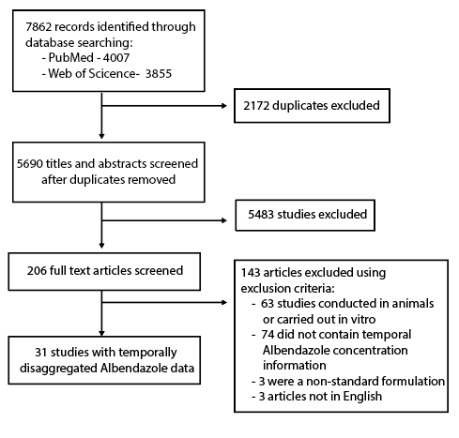

**Figure 1: PRISMA diagram illustrating the systematic review workflow.** Web of Science and PubMed were searched on 4th July 2019 using the keywords albendazole AND (treatment* OR dose* OR pharma* OR “half-life” OR “half life”). This produced a total of 5690 results after duplicate removal, of which 206 were retained for full text screening. 143 of the retained articles were subsequently excluded based on pre-defined exclusion criteria, yielding 31 studies containing temporally disaggregated data on Albendazole blood concentrations following treatment with a single dose; these 31 references contained 52 time series measuring Albendazole blood concentrations over time in different populations in total.

**Figure 2: Model Schematic**

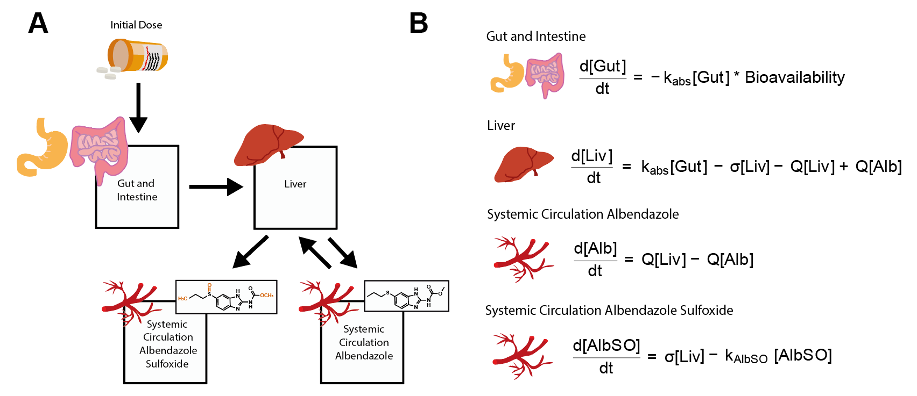

**Figure 2: Schematic of the model of Albendazole pharmacokinetics and the governing equations.** A compartmental model consisting of a series of linked ordinary differential equations (ODEs) was developed to simulate the pharmacokinetics of Albendazole and its pharmacodynamically active metabolite, Albendazole Sulfoxide, in the blood following a single oral dose. **(A)** Model schematic, illustrating the model structure and the way in which the different compartments are linked. **(B)** The ordinary differential equations governing the pharmacokinetic model, representing the concentration of Albendazole in the gut and intestine, the liver and systemic circulation, as well as the concentration of Albendazole Sulfoxide in systemic circulation.

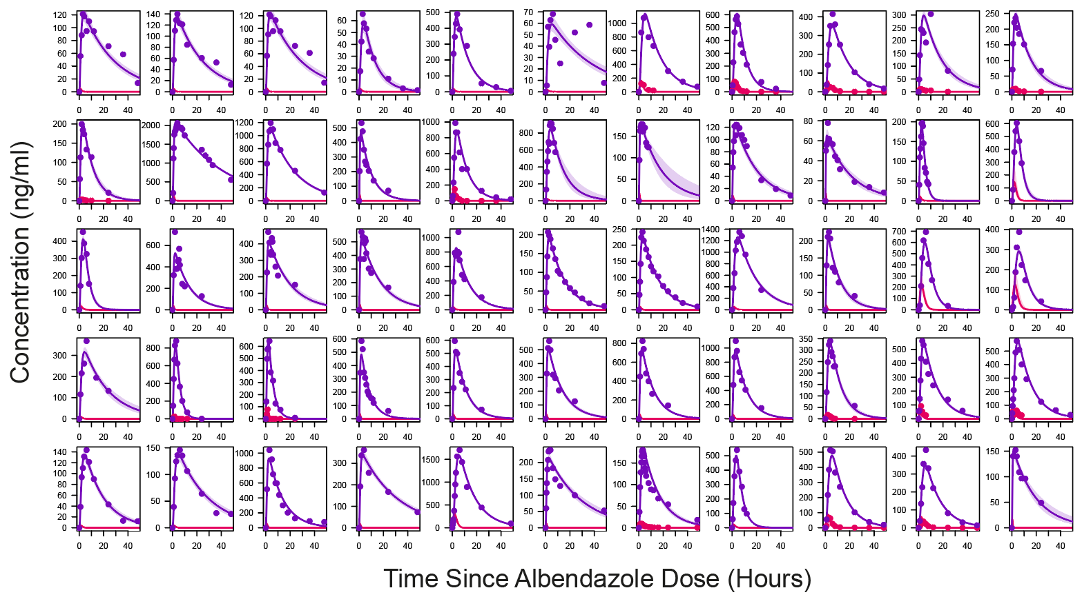**Figure 3: Model Fitting Results for All Time Series**

**Figure 3: Results of model fitting and calibration to data collated through the systematic review.** The systematic review identified a total of 55 time series containing information on the concentration of Albendazole and/or Albendazole Sulfoxide in the blood following treatment with a single oral dose. The pharmacokinetic model was fitted to these data individually using a Bayesian MCMC-based framework. This fitting was carried out in order to estimate the various pharmacokinetic parameters governing the model. For the results presented above, points represent empirical data and the lines represent model output, with the results for Albendazole in pink and those for Albendazole Sulfoxide in purple. Pale shaded area represents the 95% Credible Interval.

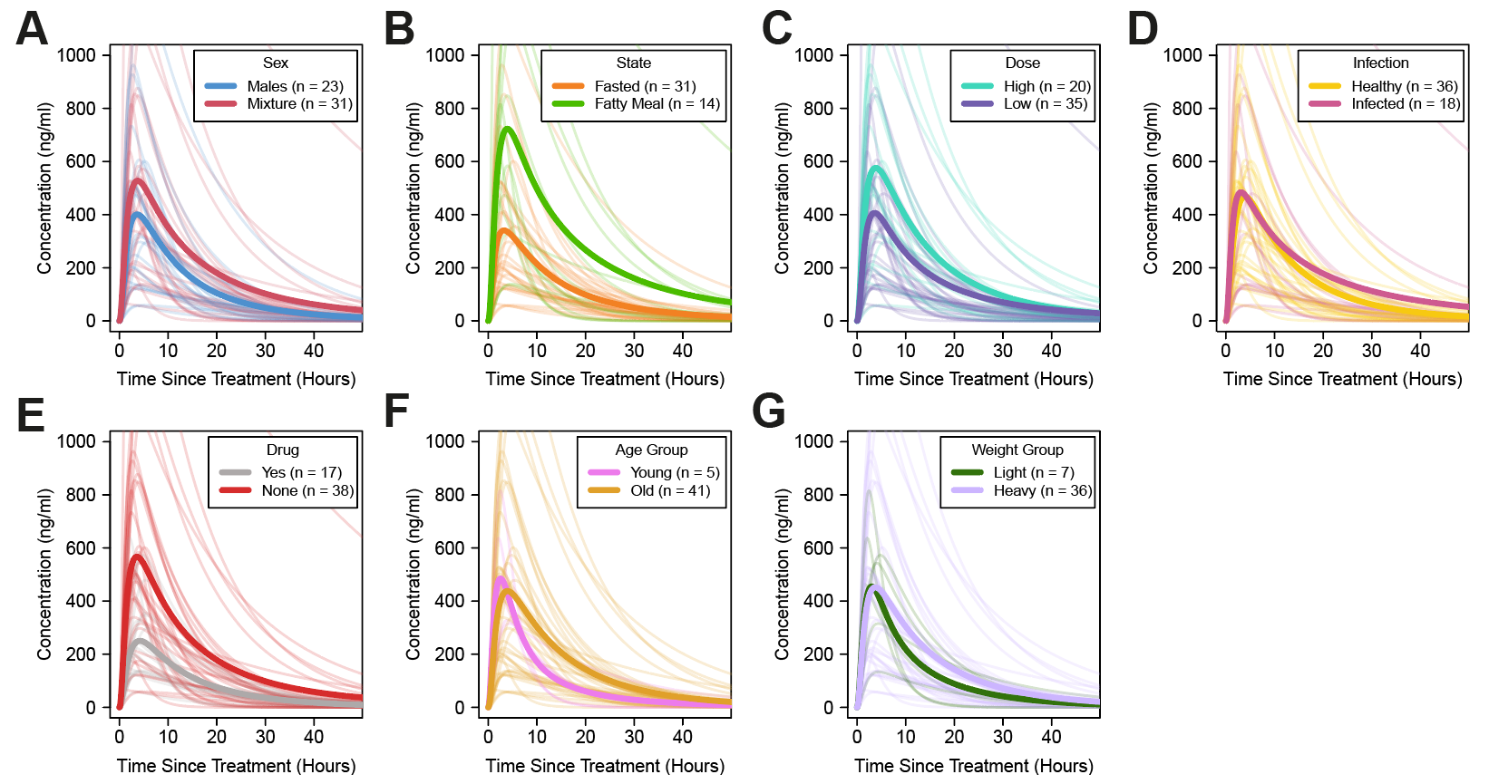**Figure 4: Graphical Exploration of Variation and Univariate Analysis of Determinants of Variability**

**Figure 4: Graphical analysis of the determinants of Albendazole Sulfoxide pharmaconkinetic variability.** Data on potential determinants of variability in Albendazole Sulfoxide pharmacokinetic properties were also collated and their impact of the modelled pharmacokinetic curve of the drug assessed. In all panels displayed above, each pale line represents the fitted model output for a single time series, with the darker lines representing the average of the time series for a given category. The factors explored were **(A)** Sex – none of the collated time series studied solely female patients and so time series were categorised according to whether the population assessed were all-male or mixed. **(B)** Feeding Status –according to whether groups had received the single dose of Albendazole whether the dose was taken alongside a fatty meal or not. **(C)** Dose – a range of different doses were used across the studies, ranging from 200ng to 1200ng. Studies were categorised according to the dosage used, with the cutoff for High/Low set at 400mg. **(D)** Infection Status –according to whether the patient population represented healthy individuals or those infected with parasitic infections necessitating treatment. **(E)** Additional Drugs –according to whether Albendazole was delivered alone or in tandem with other drugs. **(F)** Age Group –according to whether the average age of the patients was below or above 16 years. **(G)** Weight group –according to whether the average weight of the patients was above or below 50kg.

**Table 1: Regression Outputs Relating PK Properties to Characteristics.** Inferred parameters from the fitted pharmacokinetic curves, specifically Albendazole Bioavailability, Albendazole Sulfoxide half-life, CMax and AUC were regressed onto various patient population demographic and treatment metadata. The results of this multivariate regression are displayed below.

|  |  |  |  |  |  |  |  |  |
| --- | --- | --- | --- | --- | --- | --- | --- | --- |
|  | **Sex** | **Feeding Status** | **Dose** | **Drug Co-Administration** | **Age** | **Weight** | **Co-Infection** | **R2** |
| **Bioavailability** | +8.43%  p = 0.24 | +18.2% p < 0.001 | -0.004%  p = 0.23 | -7.60%  p = 0.01 | +0.159%  p = 0.44 | -0.154%  p = 0.39 | -10.3%  p = 0.05 | 62 |
| **Half-Life** | -4.90  p = 0.39 | -2.76  p = 0.32 | -0.0006  p = 0.83 | -1.39  p = 0.52 | +0.34  p = 0.05 | -0.05  p = 0.73 | +1.22  p = 0.76 | 38 |
| **AUC** | +4068  p = 0.42 | +11800  p < 0.001 | +6.281  p = 0.02 | -4560  p = 0.02 | +384  p = 0.11 | -68.0  p = 0.59 | -7900  p = 0.59 | 62 |
| **C­­Max** | +222  p = 0.36 | +641  p < 0.001 | +0.401  p < 0.01 | -273  p < 0.01 | +9.92  p = 0.16 | -3.71  p = 0.54 | -363  p = 0.04 | 70 |

**Discussion**

Despite widespread usage, significant uncertainty surrounds the pharmacokinetics of the drug Albendazole, in particular the drivers and determinants of the variation observed in individuals receiving treatment. Whilst previous studies have explored individual factors contributing to this variation, a systematic consideration and exploration of these remained outstanding. This is despite the utility that a better understanding would likely have in enabling treatment to be optimised to the patient populations receiving it. Utilising a systematic review in conjunction with a pharmacokinetic modelling approach, we synthesise a wide array of the literature surrounding Albendazole’s pharmacokinetics. Our results yield new insight into the drivers of the observed variation between individuals and populations with respect to the pharmacokinetics of Albendazole and Albendazole Sulfoxide and reveal the pronounced impact of a number of factors on different pharmacokinetic parameters.

In particular, our multivariate analyses highlighted the importance of fatty meal consumption, dose, age and infection status on Albendazole’s pharmacokinetics. Importantly, these results are a systematically observed across multiple different studies. Whilst a small number of studies have previously examined these factors individually16,22–24, it remained unclear whether these phenomena would be observed across the diverse range of patients and populations considered here, and similarly, when accounting for other patient characteristics. Additionally, our univariate analyses suggested a role for sex in affecting various pharmacokinetic characteristics of Albendazole – whilst these were not significant in the multivariate analyses, previous results have indicated a role for sex in shaping the pharmacokinetic profile of Albendazole and Albendazole Sulfoxide12. Further work is required to clarify this relationship further, but important to note is the diminished sample size available for analysis with the multivariate analyses compared to the univariate analyses (36 time series compared to 55), something that likely limited our statistical power to detect differences. Our results also indicated that different factors impact different pharmacokinetic properties of Albendazole and Albendazole Sulfoxide – for example, whilst receipt of a fatty meal was associated with increases to Bioavailability, AUC and CMax­­, Age was significantly associated with Albendazole Sulfoxide half-life. These results reveal a pattern whereby different factors differentially influence and shape different aspects of Albendazole Sulfoxide’s pharmacokinetic profile, to generate the extensive observed variation.

Another important result arising from the work presented here has been the identification of substantial knowledge gaps surrounding the populations being studied. Our results revealed a pronounced absence of studies carried out in children - only 5 of the 55 time series identified as part of the systematic review had been carried out in children under 16 years old. This is despite the widespread usage of Albendazole in infant populations as part of programmatic mass drug administration-based strategies, and despite the identification here of a significant effect of age on Albendazole’s pharmacokinetic profile. Similarly, there was a substantial bias towards male populations observed in the studies identified here: on average, studies consisted of 78% males and only 22% females, with 23 time series belonging to male-only populations, and only a single study carried out in an exclusively female population. Other areas requiring attention include drug-interactions and parasitic infections. Although data constraints precluded fully disaggregating the data, numerous interactions between Albendazole and drugs such as cimetidine14, azithromycin25 and various anti-epileptic drugs26 have been identified in the literature and an overall effect was suggested here through our analyses. Our analyses also revealed the impact of parasitic infection on Albendazole’s pharmacokinetics. This is problematic given the key groups receiving Albendazole will receive it precisely because they are infected with parasites: despite this, the majority of studies (35 of 54 where infection status was determined) were carried out in healthy populations; populations whose pharmacokinetic profiles are perhaps unrepresentative of those that might occur in infected, non-healthy populations.

There are a number of limitations to the analyses presented here. Firstly, and perhaps most notably, because of constraints pertaining to the data available in the literature, which typically presented pharmacokinetic profiles as the average of a population of patients, we were unable to work with individual data, instead, having to work with aggregated population level data. This constraint limits the statistical power of our analyses to characterise the effects of individual drivers of pharmacokinetic variability. One notable example of this is Sex – due to the lack of individual data, we were unable to explore the exact influence of Sex, and instead had to utilise population level proxies (specifically here, the ratio of males:females in the study). Despite these limitations however, the collated metadata from each study on the patient populations receiving treatment allowed us to assess and explore a wide array of factors, either directly (in the case of factors that were homogeneous across patient groups, such as fasted/fatty meal status) or indirectly (through the use of population-level proxies for age, sex, weight etc).

In addition to these constraints posed by population-level data, also important to note is that the results presented here pertain to treatment with a single dose of Albendazole. Whilst this holds programmatic relevance given the widespread usage of mass drug administration of Albendazole to treat communities for soil-transmitted helminths27, lymphatic filariasis28 and loiasis6 amongst others, it is important to note that the use of Albendazole in dedicated clinical settings for diseases such as cysticercosis and echinococcosis typically utilise treatment regimen consisting of multiple doses delivered over multiple days. Previous results have indicated that Albendazole appears to induce its own metabolism through induction of key enzymes in the liver18, and that multiple doses given over sequential days can lead to changes in pharmacokinetic properties over the course of multiple dose regimen; specifically, reductions in maximum blood concentrations of Albendazole Sulfoxide reached29. However, the magnitude of this effect and the frequency of dosing required to elicit pharmacologically relevant reductions in blood concentrations remains far from clear and has, to date, been addressed in only a limited number of studies. Exploration of this phenomena and its consequences for anti-helmintic treatment regimen using multiple doses of the drug would require both further clinical research and an extension of the mathematical model developed here, and likely represents an instructive avenue of future investigation. Similarly, extensions of the model to include infrequent but reported pharmacokinetic phenomena associated with Albendazole treatment, such as biphasic pharmacokinetic profiles (thought possibly to be a product of inter-individual variation in frequency of gastric emptying and other related characteristics30), would also likely provide new insight.

Overall however, and despite these limitations, our work provides insight into the factors contributing to and driving the variation observed in Albendazole’s pharmacokinetics. Importantly, it suggests ways in which the delivery of Albendazole in programmatic contexts might be pharmacokinetically optimised to maximise the impact of the drug’s distribution. Given the increasing frequency with which Albendazole is being utilised as part of community-based programmes aimed at controlling a wide array of parasitic infections, this increased understanding will hopefully hold important public health relevance.

**References**

1. Carpio, A. *et al.* Effects of albendazole treatment on neurocysticercosis: A randomised controlled trial. *J. Neurol. Neurosurg. Psychiatry* **79**, 1050–1055 (2008).

2. Teggi, A., Lastilla, M. G. & De Rosa, F. Therapy of human hydatid disease with mebendazole and albendazole. *Antimicrob. Agents Chemother.* **37**, 1679–1684 (1993).

3. Vlaminck, J. *et al.* Therapeutic efficacy of albendazole against soil-transmitted helminthiasis in children measured by five diagnostic methods. *PLoS Negl. Trop. Dis.* **13**, e0007471 (2019).

4. Simonsen, P. E. *et al.* Lymphatic Filariasis Control in Tanzania: Effect of Repeated Mass Drug Administration with Ivermectin and Albendazole on Infection and Transmission. *PLoS Negl. Trop. Dis.* **4**, e696 (2010).

5. Macfarlane, C. L., Budhathoki, S. S., Johnson, S., Richardson, M. & Garner, P. Albendazole alone or in combination with microfilaricidal drugs for lymphatic filariasis. *Cochrane Database Syst. Rev.* (2019). doi:10.1002/14651858.CD003753.pub4

6. Kamgno, J. *et al.* A Test-and-Not-Treat Strategy for Onchocerciasis in *Loa loa* –Endemic Areas. *N. Engl. J. Med.* **377**, 2044–2052 (2017).

7. Jung-Cook, H. Pharmacokinetic variability of anthelmintics: implications for the treatment of neurocysticercosis. *Expert Rev. Clin. Pharmacol.* **5**, 21–30 (2012).

8. Del Brutto, O. H. Albendazole therapy for subarachnoid cysticerci: Clinical and neuroimaging analysis of 17 patients. *J. Neurol. Neurosurg. Psychiatry* **62**, 659–661 (1997).

9. García, H. H. *et al.* Current consensus guidelines for treatment of neurocysticercosis. *Clinical Microbiology Reviews* **15**, 747–756 (2002).

10. Humphries, D. *et al.* Effectiveness of albendazole for hookworm varies widely by community and correlates with nutritional factors: A cross-sectional study of school-age children in Ghana. *Am. J. Trop. Med. Hyg.* **96**, 347–354 (2017).

11. Pion, S. D. S. *et al.* Effect of 3 years of biannual mass drug administration with albendazole on lymphatic filariasis and soil-transmitted helminth infections: a community-based study in Republic of the Congo. *LANCET Infect. Dis.* **17**, 763–769 (2017).

12. Mirfazaelian, A., Dadashzadeh, S. & Rouini, M. R. Effect of gender in the disposition of albendazole metabolites in humans. *Eur. J. Clin. Pharmacol.* **58**, 403–408 (2002).

13. Awadzi, K. *et al.* The co-administration of ivermectin and albendazole safety, pharmacokinetics and efficacy against Onchocerca volvulus. *Ann. Trop. Med. Parasitol.* **97**, 165–178 (2003).

14. Schipper, H. G. *et al.* Effect of dose increase or cimetidine co-administration on albendazole bioavailability. *Am. J. Trop. Med. Hyg.* **63**, 270–273 (2000).

15. Lange, H., Eggers, R. & Bircher, J. Increased systemic availability of albendazole when taken with a fatty meal. *Eur. J. Clin. Pharmacol.* **34**, 315–317 (1988).

16. Mares, S. S., Jung, C. H., Lopez, A. T. & Gonzalez-Esquivel, D. F. Influence of a Mexican diet on the bioavailability of albendazole. *BASIC Clin. Pharmacol. Toxicol.* **97**, 122–124 (2005).

17. Edi, C. *et al.* Pharmacokinetics, safety, and efficacy of a single co-administered dose of diethylcarbamazine, albendazole and ivermectin in adults with and without Wuchereria bancrofti infection in Côte d’Ivoire. *PLoS Negl. Trop. Dis.* **13**, e0007325 (2019).

18. Steiger, U., Cotting, J. & Reichen, J. Albendazole treatment of echinococcosis in humans: Effects on microsomal metabolism and drug tolerance. *Clin. Pharmacol. Ther.* **47**, 347–353 (1990).

19. Nagy, J. *et al.* Effect of grapefruit juice or cimetidine coadministration on albendazole bioavailability. *Am. J. Trop. Med. Hyg.* **66**, 260–263 (2002).

20. Jung, H., Medina, L., Garcia, L., Fuentes, I. & Moreno-Esparza, R. Absorption studies of albendazole and some physicochemical properties of the drug and its metabolite albendazole sulphoxide. *J. Pharm. Pharmacol.* **50**, 43–48 (1998).

21. Lawrenz, A., Eglit, S. & Kroker, R. [The metabolism of albendazole in the isolated perfused intestine of rats]. *Dtsch. Tierarztl. Wochenschr.* **99**, 416–8 (1992).

22. Jung, H. *et al.* Clinical pharmacokinetics of albendazole in children with neurocysticercosis. *Am. J. Ther.* **4**, 23–26 (1997).

23. Pengsaa, K. *et al.* Pharmacokinetic investigation of albendazole and praziquantel in Thai children infected with Giardia intestinalis. *Ann. Trop. Med. Parasitol.* **98**, 349–357 (2004).

24. Mirfazaelian, A., Rouini, M. R. & Dadashzadeh, S. Dose dependent pharmacokinetics of albendazole in human. *Biopharm. Drug Dispos.* **23**, 379–383 (2002).

25. Amsden, G. W., Gregory, T. B., Michalak, C. A., Glue, P. & Knirsch, C. A. Pharmacokinetics of azithromycin and the combination of ivermectin and albendazole when administered alone and concurrently in healthy volunteers. *Am. J. Trop. Med. Hyg.* **76**, 1153–1157 (2007).

26. Perucca, E. Clinically relevant drug interactions with antiepileptic drugs. *British Journal of Clinical Pharmacology* **61**, 246–255 (2006).

27. Echazú, A. *et al.* Albendazole and ivermectin for the control of soil-transmitted helminths in an area with high prevalence of Strongyloides stercoralis and hookworm in northwestern Argentina: A community-based pragmatic study. *PLoS Negl. Trop. Dis.* **11**, (2017).

28. Weil, G. J. *et al.* The safety of double- and triple-drug community mass drug administration for lymphatic filariasis: A multicenter, open-label, cluster-randomized study. *PLOS Med.* **16**, e1002839 (2019).

29. HOAKSEY, P. E. *et al.* RAPID AND SENSITIVE METHOD FOR THE DETERMINATION OF ALBENDAZOLE AND ALBENDAZOLE SULFOXIDE IN BIOLOGICAL-FLUIDS. *J. Chromatogr. Appl.* **566**, 244–249 (1991).

30. Davies, N. M., Takemoto, J. K., Brocks, D. R. & Yáñez, J. A. Multiple peaking phenomena in pharmacokinetic disposition. *Clinical Pharmacokinetics* **49**, 351–377 (2010).